**Question 1:**

**ER Diagram Question: Traffic Flow Management System (TFMS)**

**LOGICAL MODEL:**

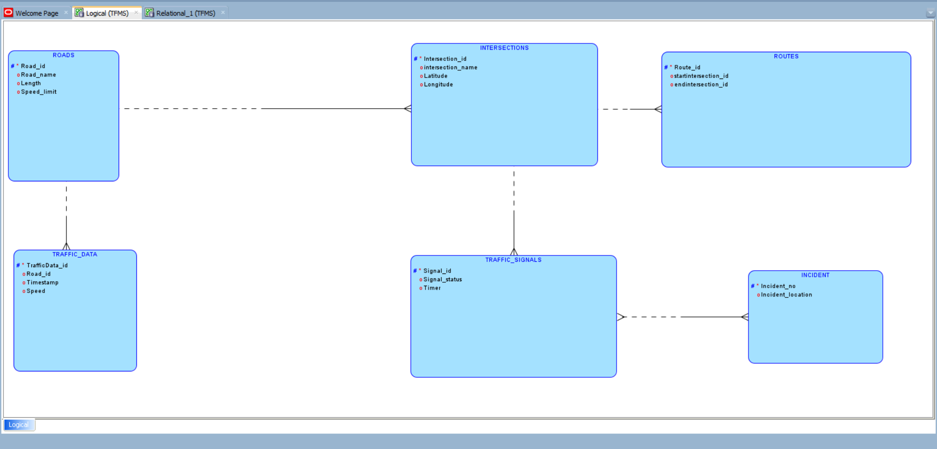

**RELATIONAL MODEL:**

